

BAHRIA UNIVERSITY (KARACHI CAMPUS)

Software Project Management (SEN-410)

ASSIGNMENT # 1 – Fall 2023

Based on: CLO-1

Class: **BSE-7A/B** Submission Deadline: **20th Oct 23**

Course Instructor: **ENGR. MAJID KALEEM** Max Marks: **04**

**Instructions:**

1. Mention all sources in the References section at the end.
2. Unload MS Word (.docx) version of your assignment.
3. Identical (copy-paste) assignments will be awarded zero marks.
4. Use proper paragraphing, headings, bullets, illustrations, etc. to ensure clarity in writing.
5. Violating any of these instructions may result in deducting marks.

# Question 1:

Describe the significance of the Project Integration Management knowledge area in software project management. What are the key processes and activities involved in integrating various project components, and how does it help ensure project success?

**Answer**

**Project Integration Management:**

It is a critical knowledge area in software project management. It encompasses processes and activities that are vital for the successful planning, execution, monitoring, and control of a software project. Its significance lies in its ability to ensure that various project components are effectively coordinated, leading to project success. Here are some key aspects of Project Integration Management and its significance in software project management:

**Project Success:** The primary goal of Project Integration Management is to ensure that the project meets its objectives and is completed successfully. This involves balancing the often-conflicting demands of scope, time, cost, and quality. It ensures that the project stays on track and aligned with the organization's strategic goals.

**Project Charter:** One of the first steps in Project Integration Management is the development of a project charter. This document formally authorizes the project and provides a clear understanding of its purpose and objectives. This sets the foundation for the project's success by ensuring everyone is on the same page regarding its goals.

**Project Plan Development:** Project Integration Management involves the development of a comprehensive project management plan. This plan outlines how the project will be executed, monitored, and controlled. It addresses various aspects like scope, schedule, budget, quality, communication, risk, and procurement management. The project management plan becomes a guiding document that helps align the team and stakeholders towards a common vision.

**Change Management:** Projects often encounter changes, and effective change management is critical for success. Project Integration Management includes processes for handling changes, assessing their impact on the project, and ensuring that they are properly integrated into the project plan.

**Monitoring and Controlling:** This knowledge area involves continuous monitoring of project performance against the project management plan. Key performance indicators and metrics are used to measure progress and identify deviations from the plan. If issues arise, the integration management processes provide a framework for adjusting and taking corrective actions.

**Stakeholder Management:** Successful projects depend on effective communication and engagement with stakeholders. Project Integration Management includes processes for identifying stakeholders, understanding their needs, and keeping them informed and engaged throughout the project.

**Closing the Project:** The final phase of a project involves ensuring that all project components are completed, objectives are met, and that the project is formally closed. This includes obtaining final approvals, conducting lessons learned sessions, and archiving project documentation.

**Risk Management:** Identifying, analyzing, and responding to risks is a critical aspect of Project Integration Management. It ensures that risks are managed in a way that aligns with the overall project objectives.

**Quality Control:** Ensuring the quality of the software is integral to Project Integration Management. It helps in integrating quality control activities into the project plan and monitoring the implementation of quality standards.

**Diagram**

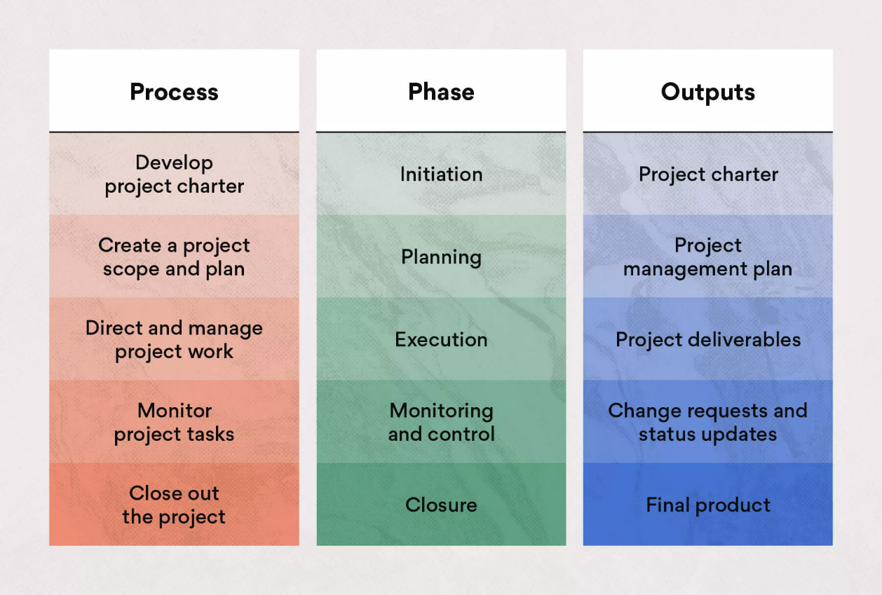

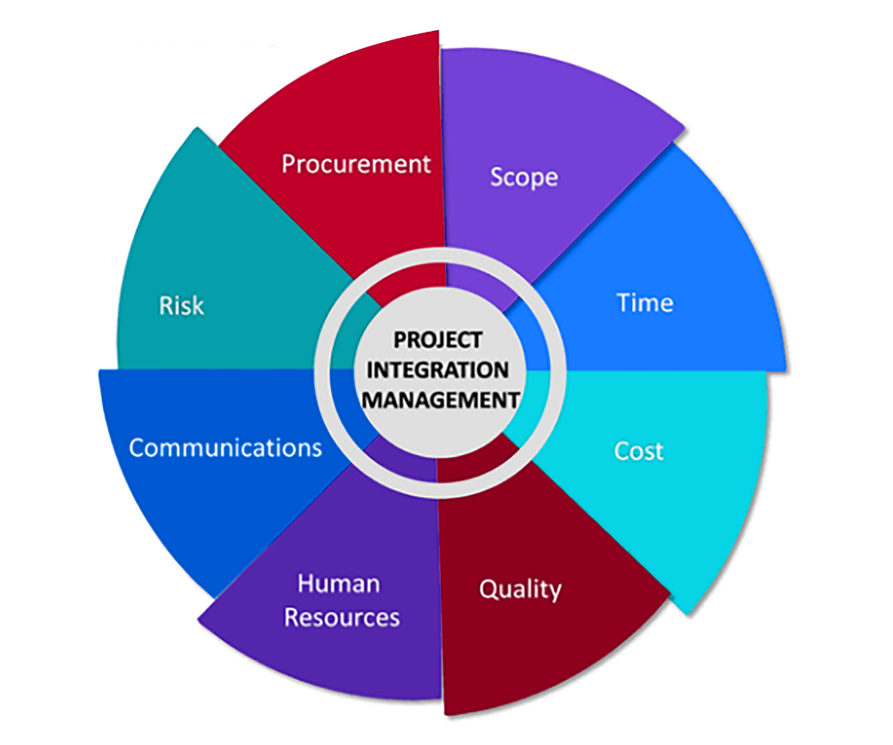

# Question 2:

Explore the Project Scope Management knowledge area within PMI's framework. Describe how effective scope management impacts software project outcomes, and what are the primary processes involved in this knowledge area?

**Answer**

**Project Scope Management**

It is one of the ten knowledge areas defined within the Project Management Institute's (PMI) Project Management Body of Knowledge (PMBOK) framework. It plays a critical role in the successful execution of projects, including software projects. Effective scope management is essential for achieving project objectives, staying within budget, and delivering quality software products. Here's an overview of Project Scope Management and its impact on software project outcomes, along with the primary processes involved:

**Plan Scope Management:** This is the initial step in scope management. It involves defining how scope will be defined, documented, validated, and controlled throughout the project. It sets the guidelines for managing scope and helps the project team understand what is expected.

**Collect Requirements:** The process of gathering detailed requirements from stakeholders, which are critical for understanding the project's objectives and what the software should accomplish. Requirements can be functional (what the software should do) and non-functional (performance, security, etc.).

**Define Scope:** This process involves documenting a detailed project scope statement that includes the project's objectives, deliverables, constraints, assumptions, and acceptance criteria. It forms the basis for project planning and provides a clear picture of what the software project will deliver.

**Create Work Breakdown Structure (WBS):** The WBS breaks down the project scope into smaller, manageable work packages, making it easier to plan and control the project. In software projects, these work packages can represent specific features, modules, or tasks within the software.

**Validate Scope:** This process ensures that the project's deliverables (in the case of software, the software features) meet the defined requirements and are approved by stakeholders. Validation helps in preventing scope creep, which can be a common challenge in software projects. ‘

**Control Scope:** Scope control involves monitoring and managing changes to the project scope. It ensures that any changes are documented, analyzed, approved, and implemented in a controlled manner. Effective scope control helps in maintaining project focus and preventing uncontrolled scope changes.

**Impact of Effective Scope Management on Software Project Outcomes:**

**Clear Understanding of Objectives:** Effective scope management ensures that all stakeholders have a clear and shared understanding of the software project's objectives, which reduces misunderstandings and ambiguities.

**Prevention of Scope Creep:** Scope management helps prevent scope creep, which can lead to budget overruns and missed deadlines in software projects. It keeps the project on track by controlling changes.

**Improved Communication:** By defining and documenting the scope, collecting requirements, and validating with stakeholders, scope management improves communication and collaboration among team members and stakeholders.

**Better Planning and Estimation:** With a well-defined scope and work breakdown structure, project managers can create more accurate project plans and estimates, reducing the risk of project delays or cost overruns.

**Higher Quality Deliverables:** Effective scope management ensures that software features are aligned with the requirements, resulting in a higher quality software product that meets stakeholder expectations.

**Client Satisfaction:** Meeting or exceeding client expectations is crucial in software projects. Scope management ensures that the software aligns with the client's needs, increasing satisfaction.

**Diagram**

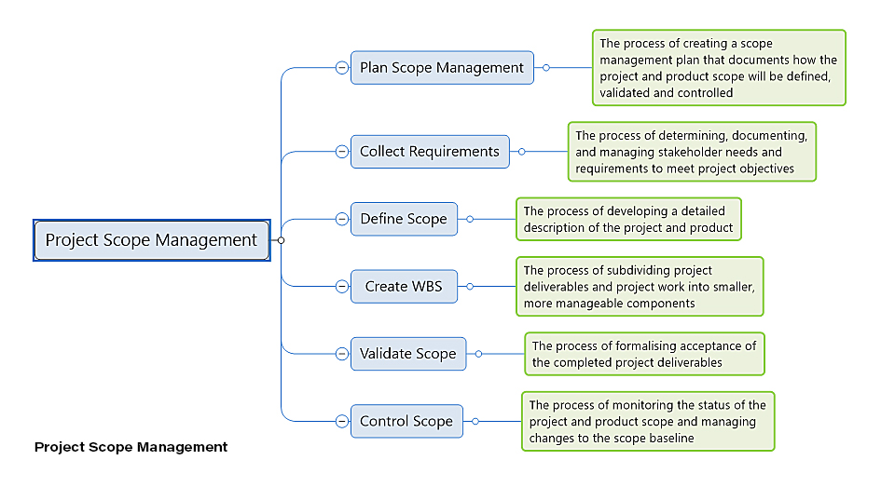

Project Scope Management is a crucial knowledge area within PMI's framework that significantly impacts software project outcomes. It helps in defining, controlling, and delivering the project scope effectively, which is essential for completing software projects on time, within budget, and with high quality.

**References**

[**https://asana.com/resources/project-integration-management**](https://asana.com/resources/project-integration-management)

[**https://business.adobe.com/blog/basics/integration-management**](https://business.adobe.com/blog/basics/integration-management)

[**https://www.projectmanager.com/blog/10-project-management-knowledge-areas**](https://www.projectmanager.com/blog/10-project-management-knowledge-areas)

[**https://www.simplilearn.com/project-scope-management-importance-rar89-article**](https://www.simplilearn.com/project-scope-management-importance-rar89-article)

Good Luck!